* **Name – Vinay Nitin Sarda**
* **Exp-6**
* **Roll No. – 23**
* **Class – S.Y.B.tech(B)**
* **Batch – B2**

**Problem Statement –**

Take file name as input to your program, If file is existing the open and display contents of the file. After displaying contents of file ask user – do you want to add the data at the end of file. If a user gives yes as response, then accept data from user and append it to file. If file in not existing then create a fresh new file and store user data into it. User should type exit on new line to stop the program.

**Program –**

import java.io.*;

import java.util.*;

public class File_Handling {

public static void main(String[]args) throws IOException{

Scanner sc=new Scanner(System.in);

System.out.print("Enter file name : ");

String f_name=sc.nextLine();

File file=new File(f_name);

if(!file.exists()){

System.out.println("Creating File...");

file.createNewFile();

}

System.out.println("Reading file contents...");

int i;

FileInputStream fin = new FileInputStream(file);

do{

i=fin.read();

if(i!=-1){

System.out.print((char)i);

}

}while(i!=-1);

fin.close();

System.out.println("\nPress Y/y to append data");

String choice=sc.next();

if(choice.equals("Y") || choice.equals("y")){

FileOutputStream fout = new FileOutputStream(file,true);

String data,ans="";

while((data=sc.nextLine()).equals("exit")!=true ){

ans=(ans+data) + "\n";

}

char []arr =ans.toCharArray();

for(i=0;i<ans.length();i++){

fout.write(arr[i]);

}

System.out.println("Data Appended");

fout.close();

}

else{

System.out.println("Terminated");

}

}

}

**Output –**

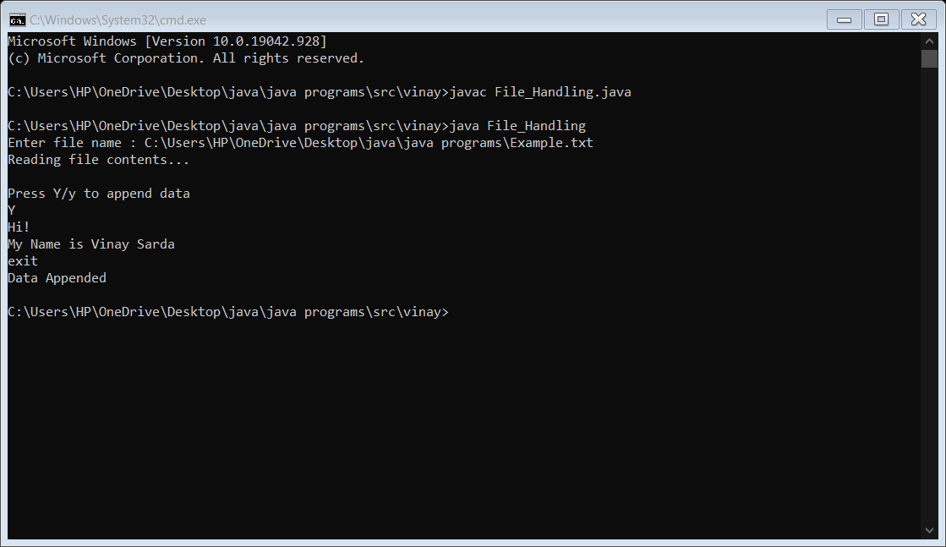

**File content –**

Hi!

My Name is Vinay Sarda